**Cloud Computing: UE20CS352**

**Experiment 4**

**-Adithya M, Section K**

**-PES1UG20CS621**

1a: Pyenv installed and local Python version changed to 3.6.8

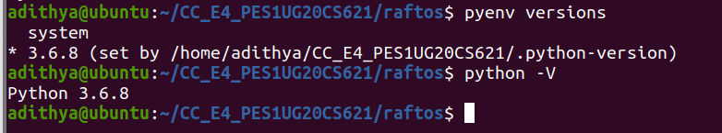

2a: Initial leader election has occurred, and first value has replicated.

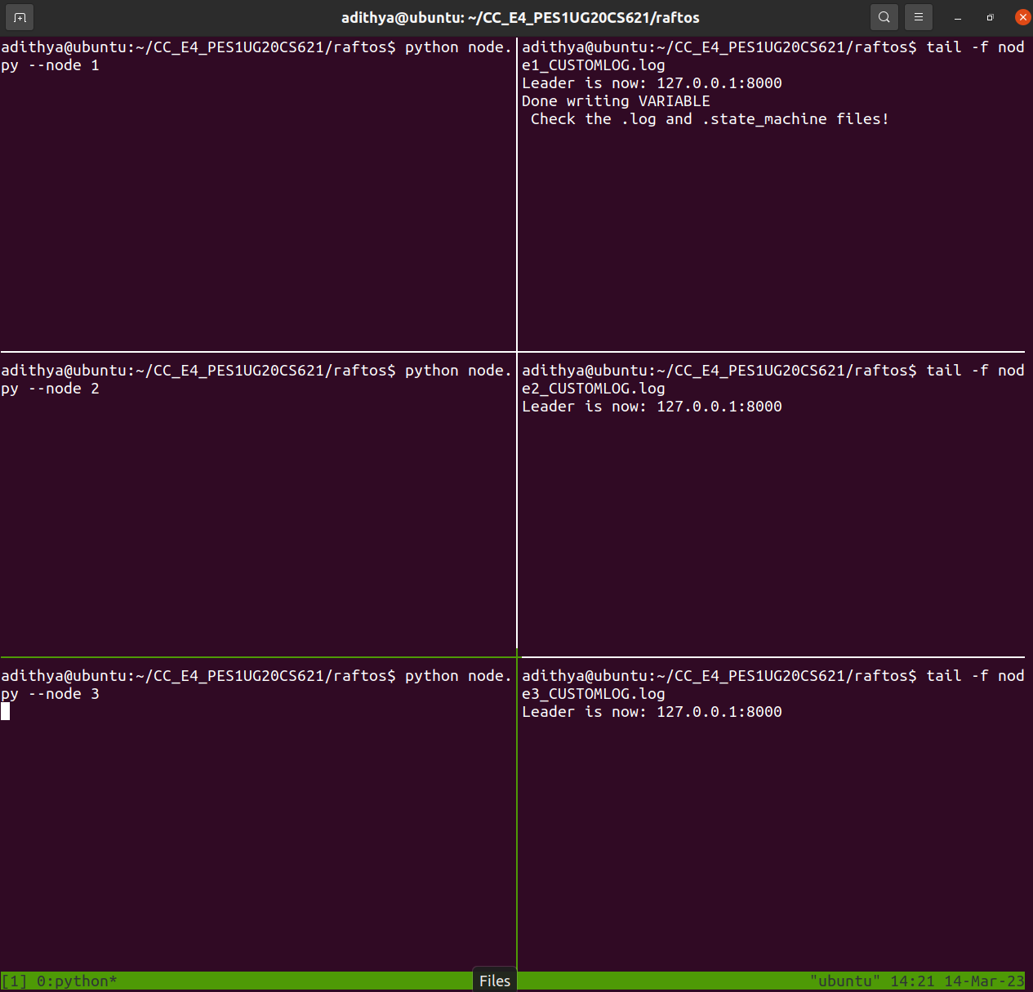

2b: Leader crashed, new leader elected, and second value replicated.

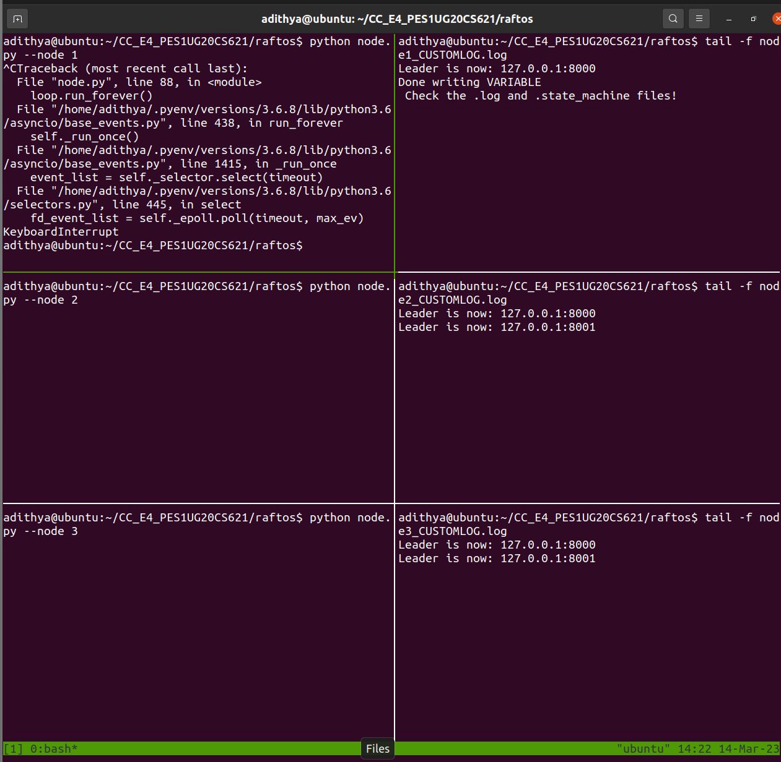

2c: Old leader comes back online, but becomes a follower instead and updates its old state to its new state

